Application for Commercial Training and Services

(To be completed in full)

NFA use only
File Number
Date received
Received by
Receipt Number
LPO Number
Invoice Processed
Application returned via
Application processed by

Type of Request: (Tick the appropriate Box/s)

Type of Training
Fire Wardens Training
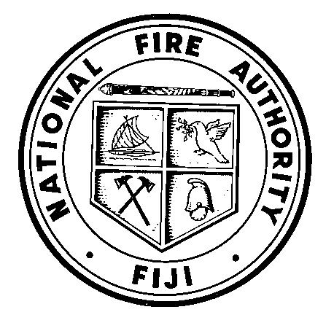
Fire Safety at Work Training
Fire Fighting Team Training
- Fire Evacuation Training

1. Address of Premises:

Premises/Company Name.…………………………………………..Site Name.…………………………………….

Street No.….Lot No.…Street Name.……………………………………….Town/Suburb…………………………

Total Number of Participants ……………………...

2. Applicant’s Details:

Applicant Name.………………………………………. Company.…………………………………………..

Street No.……Street Name.……………………………………..Town/Suburb………………………………………

Phone No...…………….…………Fax No.……….…….………… Mobile No ……………………………………

Email ………………………………

Notes I/We understand that there is a charge for this service at the rate shown on the “Schedule of Fees” accompanying this application form. Fees are to be paid upon application; the methods of payment are listed on the back of this form.

The locations for lodgement of applications are listed on the back of this form.

Signed.………………………………..Printed Name.…………………………………...…Date.……………………..

Application Requirements

NFA strongly recommend that all applicants must ensure that 2 Line Managers must be part of the training group.

Schedule of Fees:

Fees can be paid by cheque, cash or direct bank transfer to: National Fire Authority
ANZ House
A purchase order is acceptable BSB: 010 890
Account no: 1204800
Please include your name as reference

Service | Current Price (VEP) | VAT | PRICE (VIP)
Fire Fighting Teams
3 Day Training | $177.78 | $26.67 | $204.45 per person
Minimum 10 Maximum 20
Fire Wardens Training
1 day Session | $700.00 | $105.00 | $805 per session
Minimum 10 Maximum 20
Fire Safety at Work Training
Theory & Practical
Demonstration on fire safety
1 Day Training | $57.78 per person | $8.67 per person | $66.45 per person
Minimum 10 Maximum 20 Participants
Fire Evacuation Training
Theory & Practical
Evaluation Report submitted after training | $355.56 per session | $53.33 per person | $408.89 per session
1 Day Training
Minimum 10 Maximum 20
Safety at Work
Theory
Demonstration to clients on fire safety | $266.67 | $40.00 | $306.67 per session
2 hour session
Maximum 10 participants
Fire Evacuation Drill | $100.00
Assessing Fire evacuation drills at company premises and
Providing guidance and coaching. Submitting a report |  | $15.00 | $115 per session
1 hour Session

Submit Applications to:

NFA HQ (includes Central and Eastern Divisions)
Fire Station, Argo St, Walu Bay, SUVA
Phone: 331 2877 Fax: 330 3348
Email: stocommercial.nfa@gmail.com

NFA Western Division

